Project: AI Resume Parser

**Team Members:**  Adriana Altamirano, Anya Carr, Molisha Khosla, Joshua Roasa

Phase 4 Design

**Due Date February 26,2024**

In this phase, you need to include:

1. database design with an ER diagram,
2. SQL files for table creation, and Data insertion statements.
3. User Interface Design for Web pages

Things to do:

**1. ER diagram**

**2. SQL files for table creation and Data Insertion**

**3. User Interface Design for Web pages**

**IMPORTANT: CHANGED DUE DATE TO February 26, 2023**

1. Completed Create ER diagram (think about tables, attributes, strong/weak relationships, primary/foreign key) **Completed by Molisha**
2. Completed Create sql tables based on ER diagram **Completed by Anya**
3. Completed Create data insertion statements into tables **Completed by Anya**
4. Completed User interface Design for web pages (no functionality needed just design) (use the use cases as a guide to start the design for example: log in/log out, create account etc)

**Completed by Joshua and Adriana**

## 

## **Entities(PK, Data Type(varchar, INT, Date) , attributes, Relationships(1:1, 1:M, M:N))**

* Applicants
  + Applicant_ID (PK) auto increment
  + FirstName
  + LastName
  + Email
  + Password
  + PhoneNumber
  + Resume
  + Job_ID (FK)
* Recruiters
* Recruiter_ID (PK) auto increment
* FirstName (varchar)
* LastName (varchar)
* Email (varchar)
* Password (varchar)
* PhoneNumber (varchar)
* Company_ID (integer)
* Job_ID (FK)
* Job
* Job_ID (PK)
* JobTitle
* CompanyLogo (FK)
* JobDescription
* JobQualification
* Keywords
* JobLocation
* Filter
* Applicant_ID (FK)
* Resume
  + Resume_ID(PK)
  + Job_ID(FK)
  + JobTitle
  + Applicant_ID(FK)

## **ER Diagram (1 person)**

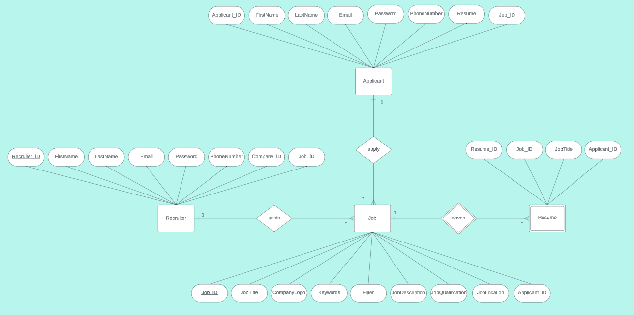

## **Creation of SQL Tables (1 person) (Anya)**

SET @OLD_UNIQUE_CHECKS=@@UNIQUE_CHECKS, UNIQUE_CHECKS=0;

SET @OLD_FOREIGN_KEY_CHECKS=@@FOREIGN_KEY_CHECKS, FOREIGN_KEY_CHECKS=0;

SET @OLD_SQL_MODE=@@SQL_MODE, SQL_MODE='ONLY_FULL_GROUP_BY,STRICT_TRANS_TABLES,NO_ZERO_IN_DATE,NO_ZERO_DATE,ERROR_FOR_DIVISION_BY_ZERO,NO_ENGINE_SUBSTITUTION';

-- -----------------------------------------------------

-- Schema ResumeParser

-- -----------------------------------------------------

DROP SCHEMA IF EXISTS `ResumeParser`;

CREATE SCHEMA IF NOT EXISTS `ResumeParser` DEFAULT CHARACTER SET utf8;

USE `ResumeParser`;

-- -----------------------------------------------------

-- Table `ResumeParser`.`Applicants`

-- -----------------------------------------------------

DROP TABLE IF EXISTS `ResumeParser`.`Applicants`;

CREATE TABLE IF NOT EXISTS `ResumeParser`.`Applicants` (

`Applicant_ID` INT NOT NULL AUTO_INCREMENT,

`FirstName` VARCHAR(45) NOT NULL,

`LastName` VARCHAR(45) NOT NULL,

`Password` VARCHAR(45) NOT NULL,

`Email` VARCHAR(45) NOT NULL,

`PhoneNumber` VARCHAR(45) NOT NULL,

`ResumeFile` BLOB NOT NULL,

PRIMARY KEY (`Applicant_ID`)

) ENGINE = InnoDB;

-- -----------------------------------------------------

-- Table `ResumeParser`.`Recruiters`

-- -----------------------------------------------------

DROP TABLE IF EXISTS `ResumeParser`.`Recruiters`;

CREATE TABLE IF NOT EXISTS `ResumeParser`.`Recruiters` (

`Recruiter_ID` INT NOT NULL AUTO_INCREMENT,

`FirstName` VARCHAR(45) NOT NULL,

`LastName` VARCHAR(45) NOT NULL,

`Email` VARCHAR(45) NOT NULL,

`Password` VARCHAR(45) NOT NULL,

`PhoneNumber` VARCHAR(45) NULL,

`Company_ID` INT NOT NULL,

PRIMARY KEY (`Recruiter_ID`)

) ENGINE = InnoDB;

-- -----------------------------------------------------

-- Table `ResumeParser`.`Job`

-- -----------------------------------------------------

DROP TABLE IF EXISTS `ResumeParser`.`Job`;

CREATE TABLE IF NOT EXISTS `ResumeParser`.`Job` (

`Job_ID` INT NOT NULL AUTO_INCREMENT,

`JobTitle` VARCHAR(50) NOT NULL,

`JobLogo` BLOB NOT NULL,

`JobDescription` VARCHAR(100) NOT NULL,

`JobQualifications` VARCHAR(100) NOT NULL,

`Keywords` VARCHAR(100) NOT NULL,

`JobLocation` VARCHAR(100) NOT NULL,

`Filter` VARCHAR(100) NOT NULL,

PRIMARY KEY (`Job_ID`)

) ENGINE = InnoDB;

-- -----------------------------------------------------

-- Table `ResumeParser`.`Resume`

-- -----------------------------------------------------

DROP TABLE IF EXISTS `ResumeParser`.`Resume`;

CREATE TABLE IF NOT EXISTS `ResumeParser`.`Resume` (

`Resume_ID` INT NOT NULL AUTO_INCREMENT,

`JobTitle` VARCHAR(50) NOT NULL,

`Job_ID` INT NOT NULL,

`Applicant_ID` INT NOT NULL,

PRIMARY KEY (`Resume_ID`),

FOREIGN KEY (`Job_ID`) REFERENCES `ResumeParser`.`Job` (`Job_ID`),

FOREIGN KEY (`Applicant_ID`) REFERENCES `ResumeParser`.`Applicants` (`Applicant_ID`)

) ENGINE = InnoDB;

SET SQL_MODE=@OLD_SQL_MODE;

SET FOREIGN_KEY_CHECKS=@OLD_FOREIGN_KEY_CHECKS;

SET UNIQUE_CHECKS=@OLD_UNIQUE_CHECKS;

## **Data insertion statements**

-- -----------------------------------------------------

-- INSERT Statements

-- -----------------------------------------------------

INSERT INTO Applicants VALUES

(DEFAULT, "Alice", "Jones", "ajones@hotmail.com","908-111-1111","/drive/AJResume.pdf"),

(DEFAULT, "Ray", "Smith", "crazyace@gmail.com","908-222-2222","/drive/myResume.pdf"),

(DEFAULT, "Rico", "Sanchez", "sanchez_rico@msn.com","908-333-3333","/drive/Resume.pdf")

INSERT INTO Recruiters VALUES

(DEFAULT, "Greg", "Heff", "gheff@hotmail.com","ice_cream@@","908-444-4444","123"),

(DEFAULT, "Bella", "Moon", "moon@yahoo.com","rice_cakes","908-555-5555","808"),

(DEFAULT, "Yoly", "Eclair", "monsta@gmail.com","smile","908-666-6666","323")

INSERT INTO Job VALUES

(DEFAULT, "Summer Intern",img,"This job consists...","php,bachelor's degree ...","Community, HTML, Future","123 Union Ave",”Remote”),

(DEFAULT, "Full Stack Job",img,"This job consists...","masters degree ...","Node.js,Agile,Google Cloud",,"321 Clark Drive","Hybrid"),

(DEFAULT, "Sales Associate",img,"This job consists...","associates degree ...","Customer Service, Passion, Lead","1000 Michael St.","Onsite")

INSERT INTO Resume VALUES

(DEFAULT,” Full Stack Job”, 123, “002”,

## **User Interface Design for Web Pages (2 person)**

### Home

#### HomePage

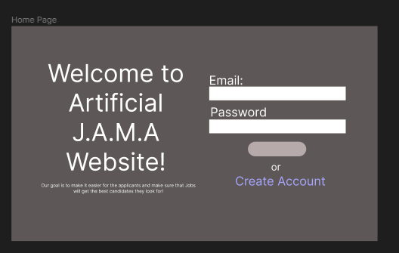

### Create Account

#### CreateAccount Page

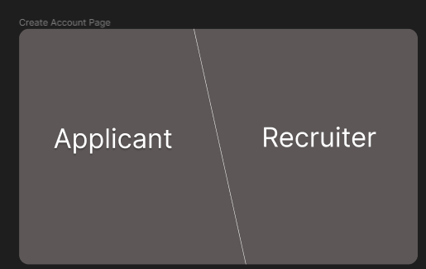

#### Applicant - Create Account

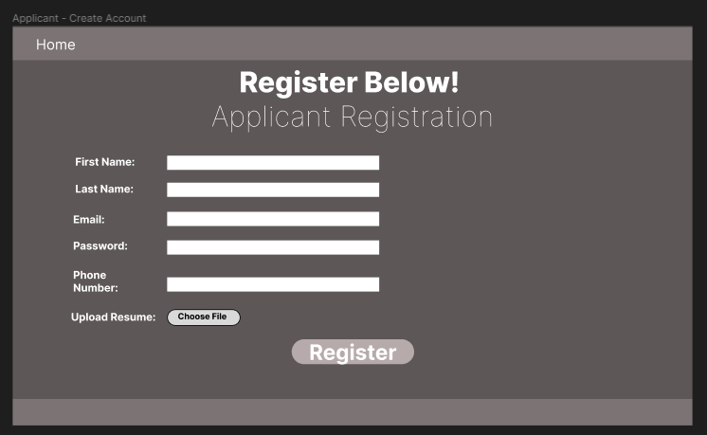

#### Recruiter - Create Account

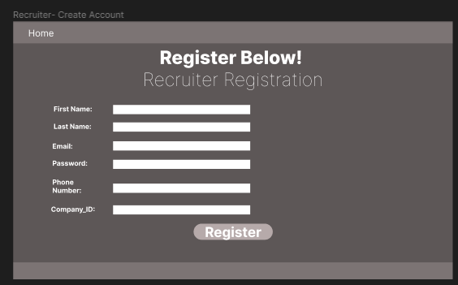

### Applicant

#### Applicant - Home Page

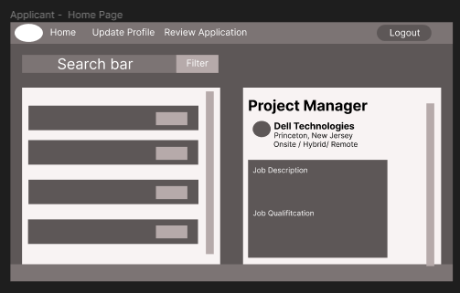

#### Applicant - Update Profile

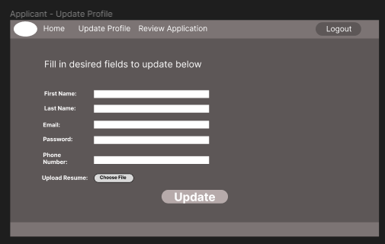

#### Applicant Draft - Review Application

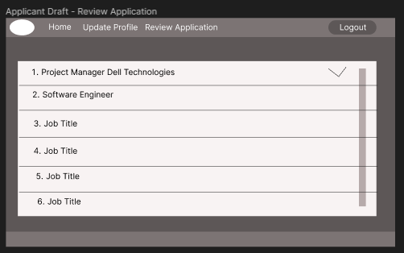

#### Application Draft - Review Application In Depth

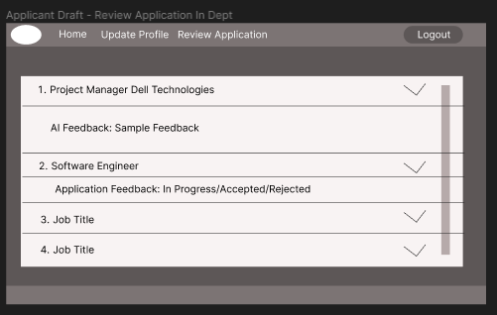

### Recruiter

#### Recruiter - Home Page

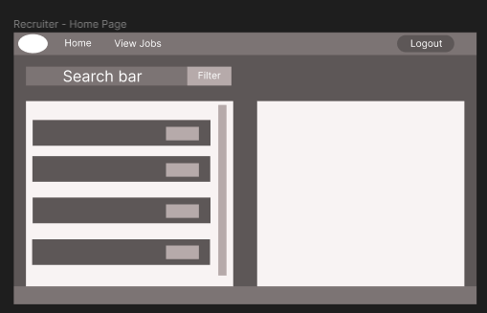

#### Recruiter Draft - View Jobs

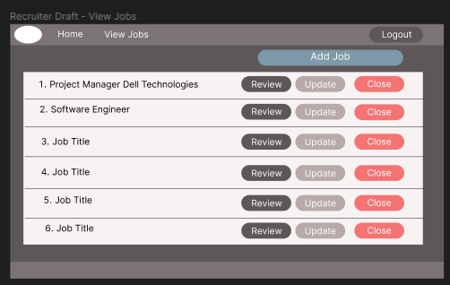

#### Recruiter Draft - Review Resume

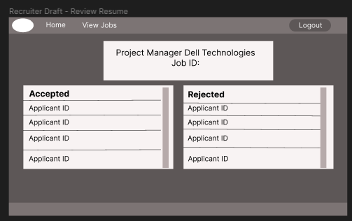

#### Recruiter Draft - Add Job

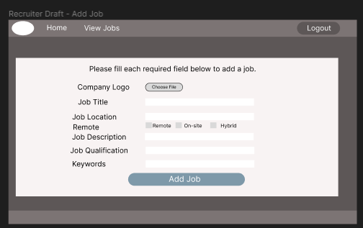

#### Recruiter Draft - Update Job

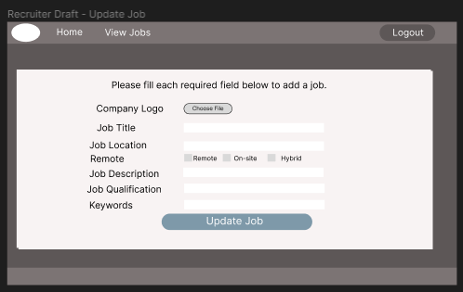

# **Timeline**

**Timeframe:**

Software Development Life Cycle(SDLC):

**~~Phase 1 Planning ( Week 1) & Phase 2 Planning (Week 1 - Week 2)~~**

~~P1 Dates: January 29 - February 5~~

~~P2 Dates: January 29 - February 12~~

1. ~~Phase 1: Identifying Problems (Planning)~~
2. ~~Phase 2: Determine Human Information Requirements (Planning)~~

**~~Phase 3 Analysis (Week 2 - Week 3)~~**

~~Dates: February 5 - February 12~~

1. ~~Analyzing system needs (Analysis)~~

**Phase 4 Design (Week 3 - Week 4)**

~~Dates: February 12 - February 19~~

Dates: February 12 - February 26

**EXTENDING DATE TO February 26 due to President’s Day Holiday and Needing more time on this phase**

1. Designing recommended system (Design)

**Phase 5 Implementation (Week 4 - Week 10)**

~~Dates: February 19 - April 1~~

Dates: February 26 - April 8

**DATES FOR THIS PHASE IS GETTING MOVED B/C WE EXTENDED PHASE 4 DESIGN**

**\*NEW START DATE IS FEBRUARY 26**

**\*NEW END DATE APRIL 8**

1. Developing and Documenting Software (Implementation)

**Phase 6 Testing & Integration (Week 10 - Week 13)**

~~Dates: April 1 - April 22~~

Dates: April 8 - April 22

**START DATE GOT MOVED B/C WE EXTEND PHASE 4 DESIGN**

**\*NEW START DATE IS APRIL 8 BUT END DATE STAYS THE SAME**

1. Testing and Maintaining the system (Testing & Integration)

**Phase 7 Maintenance (Week 13 - Week 15)**

Dates: April 22 - May 6

1. Implementing and Evaluating the system (Maintenance)

Resources:

How to save pdf to database using MYSQL

<https://stackoverflow.com/questions/3785754/how-to-store-a-pdf-file-in-mysql-database#:~:text=If%20you%20are%20simply%20looking,file%20in%20your%20MySQL%20table>.

Web design:

<https://www.figma.com/file/vvYq4GSc7AHTakg3Obj4By/Untitled?type=design&node-id=0%3A1&mode=design&t=Jb5zIYao4oDN9vPA-1>

E-R Diagram

<https://lucid.app/lucidchart/d10e90bc-72bb-4573-94bb-eb8e427a059d/edit?invitationId=inv_4c15306a-5044-4ad7-ab98-cd2936377d39&page=0_0#>